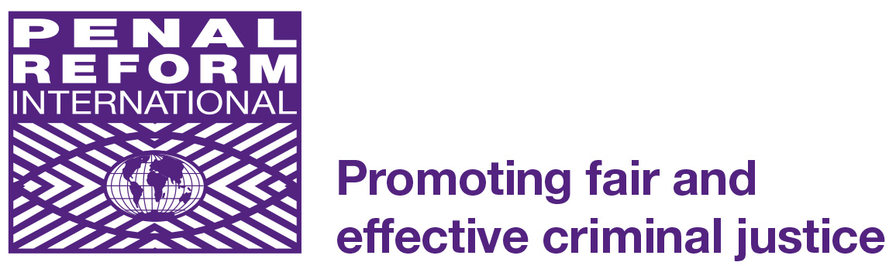
Head Office
First Floor
60-62 Commercial Street
London E1 6LT
United Kingdom

Tel: +44 (0) 20 7247 6515
Fax:+44 (0) 20 7377 8711
E-mail: headofsecretariat@penalreform.org
www.penalreform.org

PENAL REFORM INTERNATIONAL

Founded in 1989 by an international group of NGO human rights activists and criminal justice practitioners Penal Reform International (PRI) is a leading international non-profit non-governmental organisation (NGO) promoting and implementing penal reform world-wide.

The main aims of the organisation are to achieve penal reform through:

- The development and implementation of international human rights instruments with regard to law enforcement, prison conditions and standards
- The elimination of unfair and unethical discrimination of all penal measures
- The abolition of the death penalty
- Reduction in the use of imprisonment
- The use of constructive non-custodial sanctions which encourage social reintegration whilst taking account of the interests of victims

PRI works with governmental and non-governmental partners to achieve its aims. Its activities include advocacy work at international, regional and national level; implementing practical programmes of penal and criminal justice reform; and publishing training and information resources.

As well as the London Head Office, PRI has regional offices in Tbilisi (Georgia), Amman (Jordan), Astana (Kazakhstan) and Moscow (Russia). PRI has consultative status with the UN (ECOSOC) and the Council of Europe, and observer status with the African Commission for Human and Peoples’ Rights. Since its inception PRI has developed programmes in Sub-Saharan Africa, Northern Africa and the Middle East, Central and Eastern Europe and Central Asia, South Asia, Latin America, the Caribbean, and the USA.

For more information on PRI please visit our website at www.penalreform.org
JOB DESCRIPTION

Job Title: Project Coordinator (Alternatives to Imprisonment – EXTRA Project)

Responsible to: Programme Development Director

Location: London, UK

Hours of work: 35 hours per week

Contract type: Full-time fixed-term contract to 31 July 2016

Salary: £35,527 p.a.

Main purpose of the job

PRI has funding from the UK Department for International Development (DFID) for a two-year project, Excellence in Training on Rehabilitation in Africa (EXTRA), beginning on 1 August 2014 and ending on 31 July 2016. The project aims to strengthen community-based alternatives to imprisonment through testing a model of delivery of Community Service Orders (CSOs) in three pilot regions of Kenya, Tanzania and Uganda. The Project Coordinator will be based in PRI’s head office in London and will work closely with the implementing project partners, namely the Government departments responsible for CSOs in each of the countries, the research institutions, and PRI’s Project Consultant.

The Project Coordinator will manage the project, provide direction and leadership, initiate and draft proposals for continued funding of the project objectives.

Key accountabilities

- Manage the EXTRA project on a day-to-day basis, strategically and administratively.
- Manage the relationships with the Project Consultant and implementing partners to assist them in planning, monitoring and reporting outputs and outcomes within the project; and providing logistical and administrative support.
- Represent PRI at project-related meetings and events, preparing briefings and presentations, as required.
- Explore the potential for developing new contacts and projects with NGO partners and others in the region, to support and promote alternatives to detention.
- Contribute towards the development of PRI’s work in Africa by sharing learning from the EXTRA project.
- With PRI’s Programme Development Director, design and draft future fundraising proposals for the programme and linked initiatives.
- Manage the budget and provide monthly financial forecasts.
- Provide narrative and financial reports to DFID, ensure regular communication with the DFID-CHASE advisors on the project and ensure compliance with the contract requirements.

- Monitor and report progress and learning to the PPA Coordinator in accordance with PRI’s procedures and policies.
- With PRI’s Information and Communication Officer, produce reports, news items and blogs on project activities and developments to contribute to PRI’s website and newsletter.
- Work with PRI’s Evaluation and Organisational Learning Adviser, local partners and the research institutions to develop a monitoring and evaluation framework for the project and produce a final evaluation of project management and impact that can inform PRI’s alternatives work, be shared with external stakeholders and which meets DFID evaluation requirements.

The balance of these tasks will be determined by the requirements of PRI at any particular time by the Programme Development Director. In the small head office team, staff may be asked to share responsibilities from time to time in central service functions. There may be times when the post holder is asked to take part in work not specifically indicated in the job description.

PERSON SPECIFICATION

Job Title: Project Coordinator (Alternatives to Imprisonment – EXTRA Project)

Qualifications
Educated to degree level or equivalent | Essential
Post graduate qualification in an appropriate field | Desirable

Experience
International NGO project management experience | Essential
Experience of managing donor funded international projects | Essential
Experience of international human rights and development issues | Essential
Narrative and financial reporting experience | Essential
Narrative and financial reporting to the UK Department for International Development | Desirable
Experience in working in the East Africa region, specifically Kenya, Tanzania and Uganda | Desirable
Experience of partnership work, networking, advocacy and lobbying | Desirable
Experience in preparing presentations and events management | Desirable
Experience in preparing fundraising applications | Desirable

Skills and abilities
Strong project planning and management skills | Essential
Excellent organisation and time management skills | Essential
Excellent communications skills | Essential
Computer literacy including numerical skills applied on Excel | Essential
Fluent written and spoken English | Essential

Personal qualities
Excellent inter-personal skills, with patience, tact and imagination | Essential
High level of initiative, self-motivation, demonstrable ability to take responsibility and a team player | Essential
Drive, enthusiasm and commitment to PRI’s mandate and values | Essential
Willingness to service own work | Essential
Good understanding of gender and cultural issues | Essential

Circumstances
Able to work at weekends when necessary | Essential
Willing and able to travel | Essential
The post holder must have the legal right to work in the UK | Essential

Drafted July 2014

