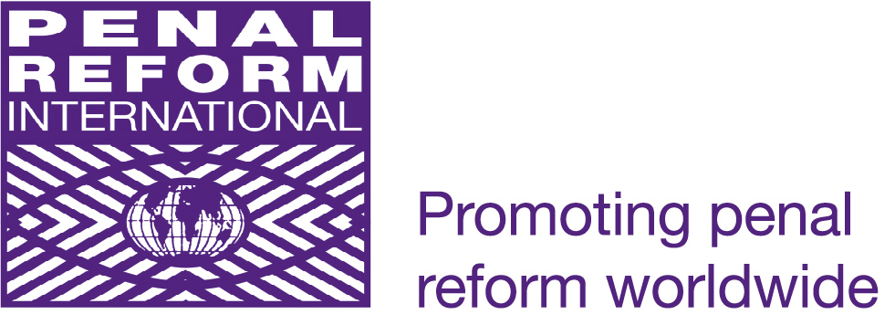

128th Assembly of the Inter-Parliamentary Union

‘From unrelenting growth to
purposeful development:
“buen vivir” – new approaches, new solutionS’

GENERAL DEBATE
21-27 March 2013, Quito/ Ecuador

Statement by Penal Reform International:
Sustainable Development and Access to Justice
Jacqueline Macalesher

Honourable Chair,
Distinguished delegates,

Penal Reform International is pleased to participate in the 128th Assembly of the Inter-Parliamentary Union and would like to thank you for the opportunity to address the plenary.

PRI is an independent non-governmental organisation that develops and promotes fair, effective and proportionate responses to criminal justice problems worldwide.

Honourable Chair,

PRI welcomes the overall theme of the Assembly on new approaches and new solutions to purposeful development.

The Millennium Development Goals set specific targets in eight major areas, which galvanized efforts to reduce poverty. While the MDGs acknowledge the multiple dimensions of poverty, they paid very little attention to inequality or social injustice, and failed to reflect the enjoyment of universal human rights as a foundation.

Sustained development can only be based on a just society, where all people, including the marginalised, can benefit from the MDGs. A society will only be just if it is based on access to justice and the rule of law for all.

As the UN Secretary General pointed out in his 2012 report ‘Delivering justice: programme of action to strengthen the rule of law at national and international levels’, the rule of law is at the heart of the social contract. It means that all persons, including the State itself, are accountable to laws, which are equally enforced and independently adjudicated, and which are consistent with international human rights standards. The UN Secretary General has also pointed out that the rule of law requires effective and equitable public services including criminal justice, legal aid and assistance.

However, in many countries, criminal justice systems are unfair and discriminatory, and cause, drive and deepen poverty, running counter to the goals of the MDGs.

People who come into contact with a criminal justice system disproportionately come from a poor and marginalised background. The reasons for this are threefold. Firstly, a large percentage of them come into conflict with the law as a symptom of their poverty, usually for small-scale offences. Secondly, not having the resources to afford proper legal representation and due to discrimination based on social status, they are more likely to be handed prison sentences. Thirdly, the social stigma of criminalisation creates a cycle of poverty that people cannot break out of, effectively criminalising poverty. People with criminal record are less likely to be able to get meaningful employment, which has a disproportionate effect on them and their families. This indirectly has negative consequences on their ability to access education and health care.

This cycle of poverty caused by criminalisation is then inherited by the next generation. As more and more adults are incarcerated, more children are left without parental support. Research shows that children of incarcerated parents have access to no or poor primary education, and are more likely than their peers to commit offences, and to abuse drugs and alcohol. This gives their poverty an enduring quality, lasting over a lifetime and often over generations.

Honourable Chair, Distinguished Members of Parliament,

There are an estimated 10 million people incarcerated globally, pending trial or following conviction. This has a striking socio-economic impact on a society.

Much of the cost of detention is born by detainees, their families and their communities in the form of lost productivity. But also at the level of state budgets, precious resources are diverted from meaningful purposes, such as health care and education, to mounting the high costs of imprisonment, while they would be much better invested in non-custodial alternative sanctions. In particular for minor and non-violent offences, non-custodial sentences equally provide accountability, but reduce the risk of recidivism and benefit victims and society better.

The overuse of imprisonment also comes with hidden costs, such as the increase in communicable diseases such as HIV/AIDS, Tuberculosis and Hepatitis in prisons, unavoidably affecting the community as prisoners ultimately are released.

We would also like to flag the disproportionate impact imprisonment has got on women, and the discrimination women face in criminal justice systems.

Honourable Chair,

To summarise, a criminal justice system consistent with the rule of law, that is fair and applied without discrimination is one of the cross-cutting issues necessary to achieving the MDGs.

While development strategies prioritise economic growth, universally accepted legal guarantees must also be mutually promoted in order to protect freedom and equality of all individuals. Without it, discrimination and marginalisation become entrenched in society, meaning that some of the most vulnerable people will never benefit from the MDGs.

Members of Parliament can play a crucial role in highlighting this dimension, in raising it with their governments and in implementing international human rights and criminal justice standards.

One such standard, recently adopted by the UN General Assembly and of particular importance to outweighing the disadvantages poor and marginalised people face when in contact with the criminal justice system are the UN Principles and Guidelines on Access to Legal Aid in Criminal Justice Systems.

Lastly, as the IPU engages with the development of the post-2015 agenda, parliamentarians and the IPU should take into account all drivers of poverty, including unfair criminal justice systems and disproportionate imprisonment, and work towards promoting and protecting the rule of law and access to justice as a founding norm for achievable sustainable development.

Countering inequalities and ensuring access to justice, including in criminal justice systems is one of the noble obligations of members of parliament.

We hope that it will give helpful impulses to the delegates, and we would like to wish all of you a successful Assembly.

Thank you for your attention.

End/

