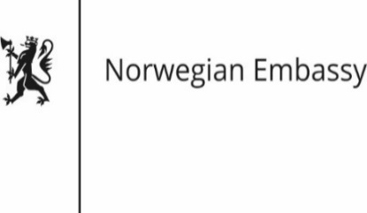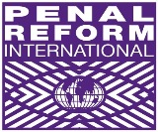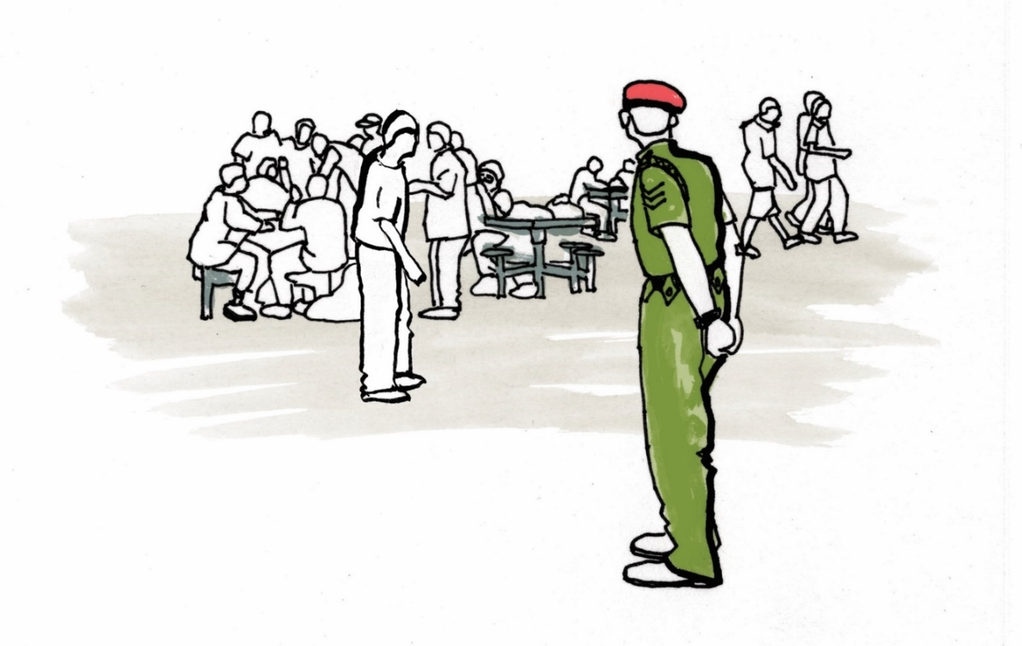

Implementation of the Nelson Mandela Rules

|  |  |  |
| --- | --- | --- |
| The General Assembly’s adoption in December 2015 of the revised UN Standard Minimum Rules for the Treatment of Prisoners - as the Nelson Mandela Rules - was described as historic by many. At this panel briefing, delegates will hear about early implementation efforts of the Rules, as well as projects and initiatives planned to assist implementation. | | Date: Tuesday 24 May, 2016  Time: 13.00 – 15.00  Venue: Mozart Room,  VIC restaurant Light lunch provided |
| Introduction and Welcome H. E. Ambassador Bente Angell-Hansen, Embassy of Norway (?)  US efforts on implementation  Ambassador Luis Arreaga, Head of US delegation  Steps towards implementation in Uganda David Nsalasatta, Commissioner Rehabilitation Services, Uganda  Steps towards implementation in Canada  Scott Harris, Correctional Service of Canada  Steps towards implementation in Jordan Samir Beno, Head of Prison Department, Jordan (TBC) | Steps towards implementation in Italy  Francesco Testa, Permanent Mission of Italy to the International Organizations  Outcome of 3rd Essex Expert Meeting Lorna McGregor, University of Essex (TBC)  Q&A  Moderated by: *Andrea Huber*, Policy Director, Penal Reform International | | |